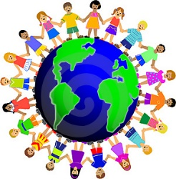What is Understanding the World?
One of the specific areas of learning in the EYFS is ‘Understanding the world’
Understanding the world is “Guiding children to make sense of their physical world and their community through opportunities to explore, observe and find out about people, places and environment” (The EYFS, 2014)
This area is important as children start to learn more about their home environment and how their world differs from their peers. Children also make sense of the world around them by exploring through their senses. When children start to discover more about their own lives it gives them a sense of belonging.
Here at Merton Poppits children have a vast range of opportunities to understand the world that they live in. In some incidents it could mean the world in its larger form, or simply there day to day routine and home life. Children in the EYFS must be provided with the opportunity and encouragement to develop the knowledge, skills and understanding that helps them to make sense of the world. Their learning must be supported through offering opportunities for them to use a range of tools safely; encounter creatures, people, plants and objects in their natural environments and in real-life situations; undertake practical ‘experiments’; and work with a range of materials.
How we meet ‘Understanding the World’
There are three individual sections which make up this area of learning, they are:
• People and Communities
It is important for children to talk openly about their home life about things that have happened in the past or present. It is also important that the children have the opportunity to learn about their peers families and how they may differ to their own family. To support this we have small group times three times a day where children sit in their small groups and have the opportunity to talk about their weekend and listen to others. We have a ‘home corner’ where children can role play what they have seen their parents do at home, such as making dinner, sweeping the floor or washing up. Children also can explore people and communities in the quiet corner where there are a selection of books about families around the world and how they live in comparison to us.
At the setting we have different culture days frequently which celebrate the differences of others, for example ‘4th July’ we would tailor activities which would take place in America, ask our American families to bring in food, music and pictures to share with the other children. The toy boxes in the setting are labelled with different languages so the children have the opportunity to look at different print.

• The world

The world explores differences and similarities in places, objects, materials and living things. Observations of animals and plants and talking about why changes occur.
In the art corner children have the opportunity to print with natural objects which they have collected themselves such as; leafs, vegetables, fruit and sticks.
Inside we have a natural box of objects the children can explore and sort, they can also add to this box when they come into the setting morning or afternoon.
In the garden we have planted plants with the children and potatoes, they have their own garden tool set which is readily available to them when they go outdoors. The children watch as they grow and take responsibility in watering them. Staff members take pictures of the changes so the children have a visual of the changes. A quote from our most recent Ofsted report “In the outdoor area, children readily share out the magnifying glasses to search the cobwebs and remaining sprout plants for insects”
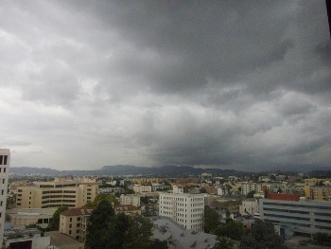
• Technology

Children learn how to operate things and the purpose for doing so.
In the setting we have numerous toys and games that require the children to think in order to get their desired reaction. If a child asks a question an adult would use the laptop to explore the question asked with the child. The children help to take photographs outdoors and display them indoors and out
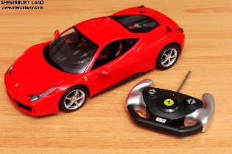

Activities to do at home:

- Digging holes and growing things – cress, beans and sunflowers are always good as they are interesting whilst they grow
- Going for a walk in the local area (see shape walk, bear hunt, colour walk and baby animal walk for some ideas)
- Talking about places in the community and reading books about children’s experiences there – the police and fire station, the doctors surgery or vets, the hospital or airport, the park, library or school
- Singing songs e.g. Old MacDonald had a farm or play games like Cock-a-doodle-moo! to listen to animal noises
- Using digital cameras, computers, torches, walkie talkies and other technology
- Making maps of the local area
- Looking at shadows (can you manage to run away from yours? can you make shadow shapes?)
- Exploring senses – using ‘feely bags’, musical instruments /sound blocks, smelly bottles
- Celebrating different festivals
- Mixing coloured paints together to see what happens
- Talking about the weather and look at what you wear in different weather conditions
- Junk modelling
- Using real tools and equipment in construction activities
- Building dens / camps / tents and other transient structures
- Looking at books / playing with resources which explain different cultures, beliefs, gender and disability
- Star gazing
- Experiencing road and water safety ideas through puzzles, games and discussions
- Role playing either pretending to be Mum, Dad, or even a doctor or nurse.

