Inset Day – January 2016  How do we support children’s next steps and develop IEPs | FIndings:  We need to use clear words on IEPs and break down the goal into the jobs that will help towards the end goal.  Shannen Watts  Portage training

Inset day: Monday 5th January 2016
- Use clear words when writing IEPs, not cloudy words.
Words such as identify. Words that
You cannot see the results. Always think: What will I see.

2)We discussed how many steps it would take to pour a drink:
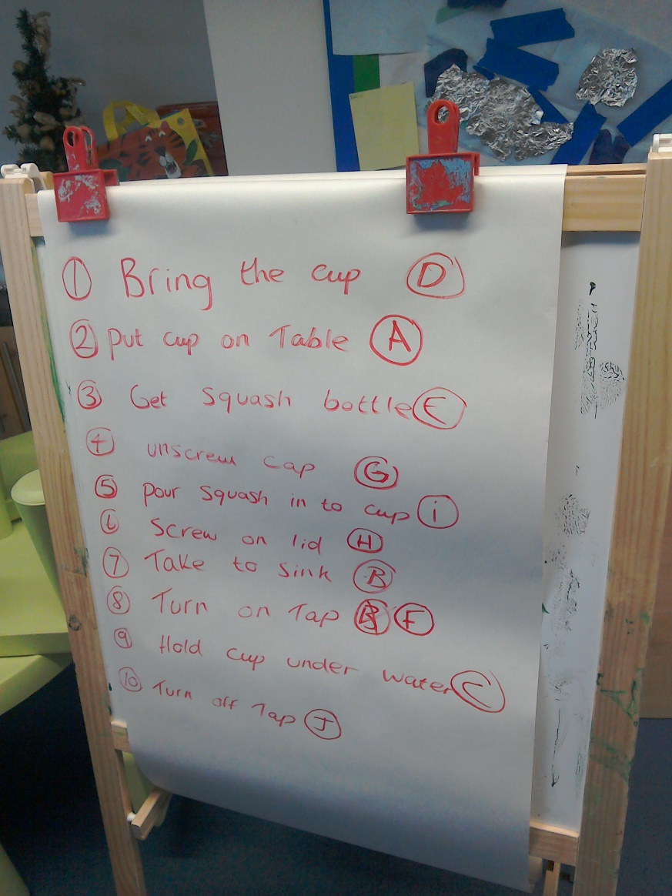
We discussed which order the skills should be taught from easiest to hardest.

4) To support children with independent skills staff should use chaining,
Forward chaining is when the adult helps with the first task.
Backward chaining is when the adult helps with the last task first.
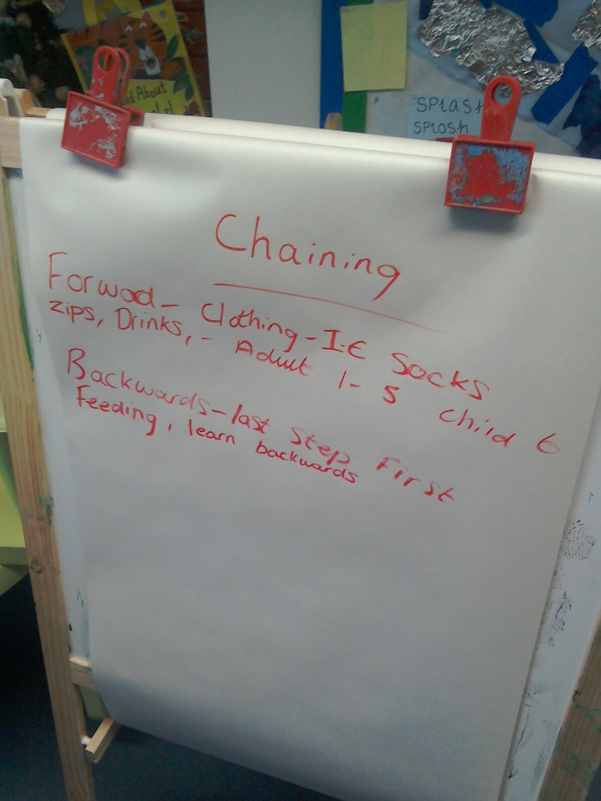
5) When writing IEPs, staff need to think:
Who? Child’s name: Timmy
Does what? What the adult will do: Will select a puzzle to do with a peer.
Under what conditions? What is child expected to do, what is the adult going to verbalise? How many do you want the child to complete? Timmy will fit 3 pieces together, hand over hand support from an adult. The adult will say “put the pieces together Timmy.”
For how long? For how long the activity will take place and how often: Timmy will sit for at least 30 seconds at least once every day with an adult and a peer.
If a child enjoys the activity change the criteria. Always start with lots of support, rather than add support.

6) Fail safe learning
Ensure children cannot fail:
Sorting – One huge teddy bear and one small teddy bear.
- Lots of red colours and 1 blue, when teaching blue.
Always ensure:
- There are none or few distractions
- Prompts
- No. of choices
Never change an IEP if the child has only completed the step once. Ensure the child has completed the task lots of times, and embedded the learning.
7) All staff got in to pairs to do a listening activity, where 1 person was distracted and the other was talking for 1 minute.
Staff described the experience as:
Uncomfortable

Rude

confusing
Irritating
difficult

This taught us that we MUST listen to children and parents without interrupting or judgement.

Training evaluation:
“I learnt a lot about the skills needed to teach SEN children.”
“Yes, made me think about how many small transitions there are within basic routines.”
“Wasn’t 100% sure what to expect.”
Staff said that they will start doing now as a result of this training:
“Bring in new ideas into my work/paperwork.”
“Looking at smaller targets for writing IEPs”
“Ensuing IEPs are being followed and speaking to Shannen when I feel the need to.”
“Chaining”
“Thinking about IEPs in more depth.”
“Chaining, forward and reverse. Thinking about speech and expectations.”
Staff said that they will stop doing now as a result of this training:
“(using) cloudy speech”
“Panicking about IEPs”
The staff said that they will ensure positive outcomes for the children by:
“That IEPs are being followed, so children’s skills can be focused on.”
“Better IEPs”
“Following new IEP structure.”
“Listening to both (children and parents) showing by asking questions.”
“Give them more opportunities.”
“Use of clearer language.”
The staff will support the home learning environment or support parents by:
“Clearer IEPs.”
“Will help with IEPs.”
“Listening more closely to parents and children.”
“Can share IEPs with parents. Listen to parents worries and concerns about children.

