Personal, Emotional and Social Development
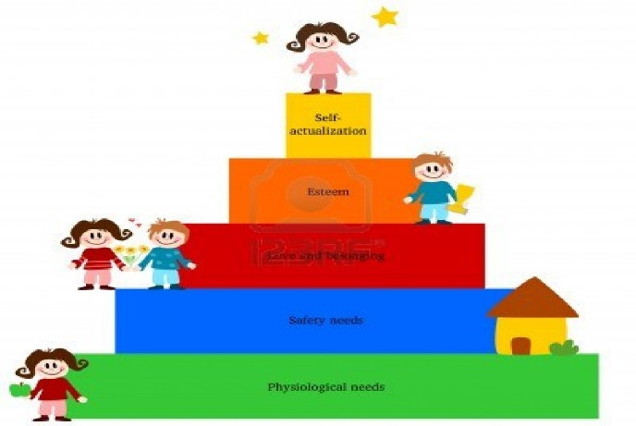
Personal, Social and Emotional Development (PSED) is important because it is a prime area of learning in which is broken down into 3 areas: making relationships, self-confidence and self-awareness and managing feelings and behaviour.
Children learn every day to make new friends, learn about new feelings and talk about home lives in order for them to naturally develop in the area of PSED.
At playgroup we use lunchtimes and other important events of the day to encourage children to become more confident in the routines of the setting.
We encourage the children to communicate with others, make new and maintain relationships through home visits, small groups and encouraging children to play with each other.
In the quiet corner, children in small groups or individually read stories, sing songs, look at a range of feelings masks or just have a rest. Adults promote children’s learning of PSED throughout all activities by giving them lots of praise to build their confidence. In our small group ‘teams’ once a week the key person uses the PATHS scheme which help children to develop emotions and feelings in a positive way and educational way using puppets and stories.
At home you could help your child develop in the area of PSED by having puppet shows using sock puppets and stages for puppets from cardboard boxes, parachute games with old pieces of material, playing snap, reading stories that portray feelings, dressing up together, eating meals with the family at the table and turning stories into a mornings activity for example ‘We are going on a bear hunt’ can be turned into ‘we are going on a sock hunt’.

