Physical Development – PRIME AREA
Physical Development is very important for young children as it as it encourages them to be active.
Physical Development is broken down into 2 areas: Moving and handling, health and self-care
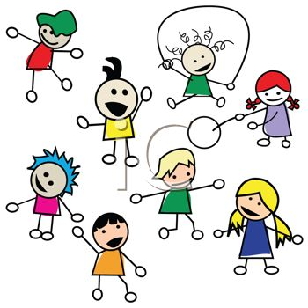
Fun Fact:
Children need to develop muscles by moving around, in order for them to sit still.
Encouraging children includes helping them to develop their co-ordination and control within small and large movements using the space around them.
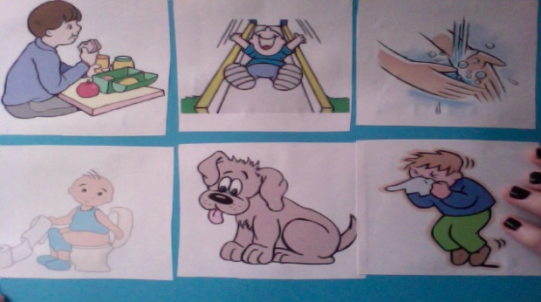
At Merton Poppits we talk to children about keeping themselves healthy and safe, and encourage them to develop independence in this area. This will help them to understand basic hygiene and personal needs.
Physical Development is encouraged and explored in all areas of the setting at the playgroup from turning pages in a book, to building a road and pushing around cars. At the playgroup we use outdoors there is lots of opportunity to encourage physical development, children are encouraged to run around, climb the frame, ride bikes etc.
At home you can encourage your child by: walking to the park, (climbing is very good for writing skills) swimming, riding their bike, dancing, painting, playing with small objects.
Start encouraging your child to dress themselves. Start them with 1 piece of clothing. Always do this when you’re not in a hurry, give them plenty of time to get it wrong. Even if they get it wrong say “good for trying to put on your … it is upside down/back to front.” So next time they may try a different way.

