Literacy Development
As part of the areas of learning, Literacy is a specific area which involves encouraging children to listen have a love of books, and start mark making which will lead on to reading and writing once they are in Reception age.

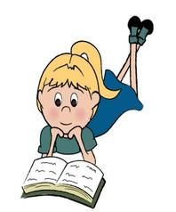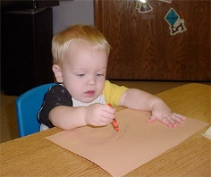

Here at Merton Poppits we strive to encourage our children in many different ways. We have a wide selection of fiction and non-fiction books indoors and outside. We also have picture books, story books, cd story books and books with flaps or touch and feel materials. We use puppets and props to encourage children to relate to the story. We have a cosy quiet area inside and outside to sit in and read comfortably.
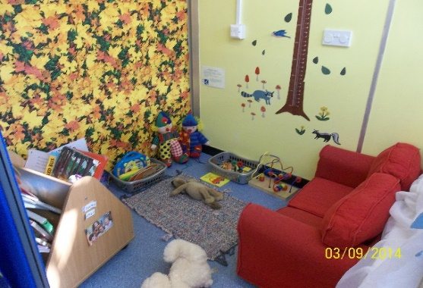

We use name cards to support the children using phonic sounds to recognise their own name and which letter it begins with. These name cards can be stuck to our mark making table to help encourage the children to write their name.

All areas are labelled in writing and by picture. We also use dual language books and labels to raise awareness of different scripts. Outside we love to encourage den building to make quite areas to read in.

At home it is especially important to look at books and read stories together. You can also join your local library/discovery centre who have a wonderful range of children's books. The library also run story telling session once a week which is well worth a visit.
http://www3.hants.gov.uk/library/bsdc.htm (Basingstoke discovery centre website)

