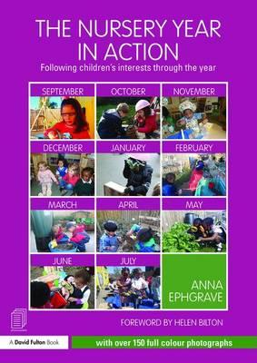

In the moment planning
  - Inset day
Shannen Watts | In the moment planning | 31st Oct 2016

What does in the moment planning mean to each practitioner:
Each member of staff wrote down what they think in the moment means.
- Responses were planning from the child’s interest, observing the child, narrating play.
Shannen stated that it means
- Seizing the moment,
- Based on what the children are ALREADY deeply involved in,
- Planning in the moment is all about capturing the moment of engagement and running with it to make sure the children progress.
- There is NO forward planning.
Quote from Nursery in action:
“Teaching is all of those different things you do as an adult that help young children learn, communicating, modelling language, working with children as they initiate their own play and activities; being ready to intervene on the moment, demonstrating how to do something, explaining why something is as it is, showing children something, exploring ideas with them, encouraging them, questioning them, checking what it is they are understanding, helping them to record something that they did so that they get the structure and sequence of events, providing a narrative for what they are doing, commenting on what they are doing, setting challenges, all those sorts of things are the sorts of things we mean when we are teaching.”
“This type of planning needs the skills to be able to see the teachable moments.”

What is the practitioner’s role?
- Skilled practitioners need to know when to intervene and when to stand back and observe.
- The skill to be able to see the teachable moments from the child’s perspective.

WHat to do in November.
Need to establish routines
Staff discussed what we need to in order to establish routines:
- Establishing golden rules with the children.
- Model tidy up time.
- Be consistent
- Ensure slippers and shoes are put away in the correct places.
Start with the first round of focus children
- Discussed the focus children list
- Decided on the 1st focus children
Continue with parent’s meetings
Review Environment and resources
- Carey to assess environment using ECERs
2 small groups at end of sessions
- Reflective small groups, about what they have done during the session. For example: Story scribing, showing what they made, encouraging children by saying “I noticed that Ryan was playing at the water tray…”
Nursery in action quotes:
“November is the harder month of the year…It is one of the few months without any holiday break…The weather is often wet and cold…making outdoor learning challenging…a constant stream of changing coats. (An easy way of changing coats) The coat is placed on the floor, or on a table, open and upside down. The child puts their arms in the sleeves and lifts the coat over their head!”
Discussed establishing an outdoor policy, (see page 52 in Nursery in action) This policy should include: Getting wet does not cause us to catch a cold. If the cold virus is around, we will pick it up regardless of whether we are wet or dry.

Documenting
We are going to use Tapestry to document the focus child’s wow moments and learning. We shall have a place to write quick observations where staff can record short notes to look back on later.
The whole point of in the moment planning is to ensure that staff spend time with the children ‘teaching’ and should documenting should be short and meaningful.
There will be 2 focus children per week, which the child’s key person and other staff will observe the children and record what the child is interested in and plan to enhance the provision.

Parent involvement
A pack that includes a camera and parent contribution sheet/home observation will be sent out to the focus child on the last day they attend of the week. The pack needs to be sent back on the next time they are at Pre-school.

The focus child
Staff made list of focused children from November to April. New children will be added to the list as and when they start Pre-School.

Schemea
Staff went through what schemeas are and how we can enhance schemas of children. A Schemea sheet will be sent out to staff and children.

