Expressive arts and Design
Expressive arts and design is a specific area. Although children younger than 3 will be supported to develop skills in this area. Only children over 3 (or who are achieving well in the prime areas of learning) will be assessed in this area of learning.
Expressive arts and design is an important learning development for a child as it encompass all of the child’s creative skills. Children are born creative, and the environment and the adults around the child can enhance and develop creativity in a child.
In the EYFS Expressive arts and design are broken down into 2 sections:
- Exploring and using media and materials
Children naturally explore surroundings, and children who are not able to should be supported by caring adults to explore everything. All children will be encouraged to use their 5 senses to explore.
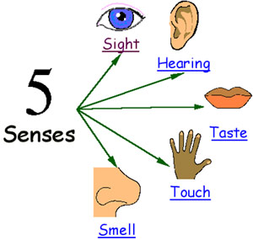
At the playgroup we try to use natural and real objects. For example: real objects such as real china plates in the role play. Children are supported in order to handle the equipment safely and responsibly by the adults in the setting. The real objects help children to develop their senses as they feel different, smell different, taste different, smell different and even the sound of real objects is different to plastic pretend objects.
We offer a range of materials in the art corner that children are free to use in their creations. We always have a malleable material such as play dough, clay or plasticine, as well as paints, glue, sticky tape in order to explore and create.
The second section of Expressive arts and Design in the EYFS is:
- Being Imaginative
Children around 18 months start to imitate the world around him or her. For example start to cook, clean like their parents. Children start to realise that objects can stand for other objects e.g. a saucepan becomes a helmet for an astronaut.
We ensure all areas are well stocked with open ended resources, inside and outside. This means imaginative play can happen throughout the setting. For example we have tubes in the construction that children can use as tunnels, as arms for a superhero, as a bin to put toys into. As well as outside the tubes can be used to hit as a drum, or run water through.

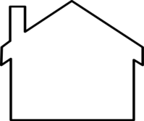
Recourses and ideas we love:
Very simple play dough recipe
Mix together:
1 cup of flour,
1 cup of salt,
And add slowly as you mix, so it is not too sticky or too dry.
To make the play dough interesting add:
Food colouring, glitter, pasta, cars (to make tracks), rolling pins, sauce pans.
When you visit places such as doctors, or shops…
Offer equipment that children could use to role play with such. Such as if you go to the shop: a play till, and some tins of food, some real pennies or pretend money. Take it turns to be the shop keeper and shopper.

