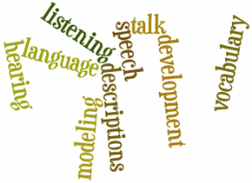
Communication and Language Development
Communication and Language (CL) is one of the prime areas of the Early Years Foundation Stage (EFYS).
CL development can develop quickly in response to good relationships and experiences. CL supports learning in all other areas of learning. Listening and Speaking are the foundation of reading and writing.
In our setting we support children’s listening, speaking and understanding skills by following the Letters and Sounds programme (https://www.gov.uk/government/uploads/system/uploads/attachment_data/file/190599/Letters_and_Sounds_-_DFES-00281-2007.pdf).
We implement small group activites that are based on the children’s intrests, stage of development and that are age appropriate.
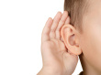
We take the children on sound walks to listen and distinguish between sounds in the enviroment.

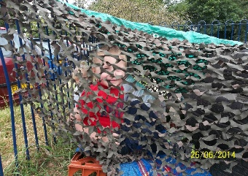
We provide communication friendly spaces where children can communicate on a 1:1 basis.
Makaton is used in the setting to aid communication and understanding.
At home you could:
- Play with your child, turn off the TV, put away the tablets and turn off the phone. Get down and play on the floor with your child. Say what they are doing for example “Tommy is pushing the blue car down the ramp.” Do not ask too many questions. Leave gaps for your child to respond.
- Learn some Makaton signs and use these as well as speech when talking to your child.
- Sing songs and rhymes with your child. If you do not know any ask your key person or look for some on Youtube, such as baa baa black sheep or hickory dickory dock.

